2019 Southwest Regional Conference
Theme: Anchored in the Lord (Hebrews 6:19)

YOUTH AGENDA
Monday, June 24, 2019
- 8:00 pm Meet and Greet

Tuesday, June 25, 2019
- 8:00 am – 10:30 am Christian Education / Classes
- 10:45 am – Noon Morning Service
- 2:00 pm – 5:00 pm Rehearsal
- 7:00 pm – 8:00 pm Opening Ceremony
- 8:30 pm – 9:30 pm Old School Game Time

Wednesday, June 26, 2019
- 8:00 am – 10:30 am Christian Education / Classes
- 10:45 am – Noon Morning Worship
- 3:00 pm – 6:00 pm Aquarium of Long Beach (Depart 2:30 pm)
- 7:00 pm – 9:00 pm Rehearsal

Thursday, June 27, 2019
- 8:00 am – 10:30 am Christian Education / Classes
- 10:45 am – Noon Morning Service (Youth Presentation)
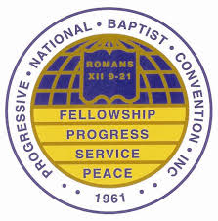
- 2:30 pm – 5:30 pm Ship Guided Scavenger Hunt
- 7:00 pm – 8:00 pm President’s Night
- 9:00 pm – 11:00 pm Real Talk, Real Praise

Special Note:
- Children are required to attend all scheduled events outlined above (including classes)
- *Offsite event - Children MUST be registered for the PNBC in order to attend
- Represent your 2019 PNBC T-Shirt or your church T-shirt during off site events
- 2019 PNBC T-Shirt will be worn during youth service Thursday morning
- Contact Angela Riley at 216-235-6591 for any questions

