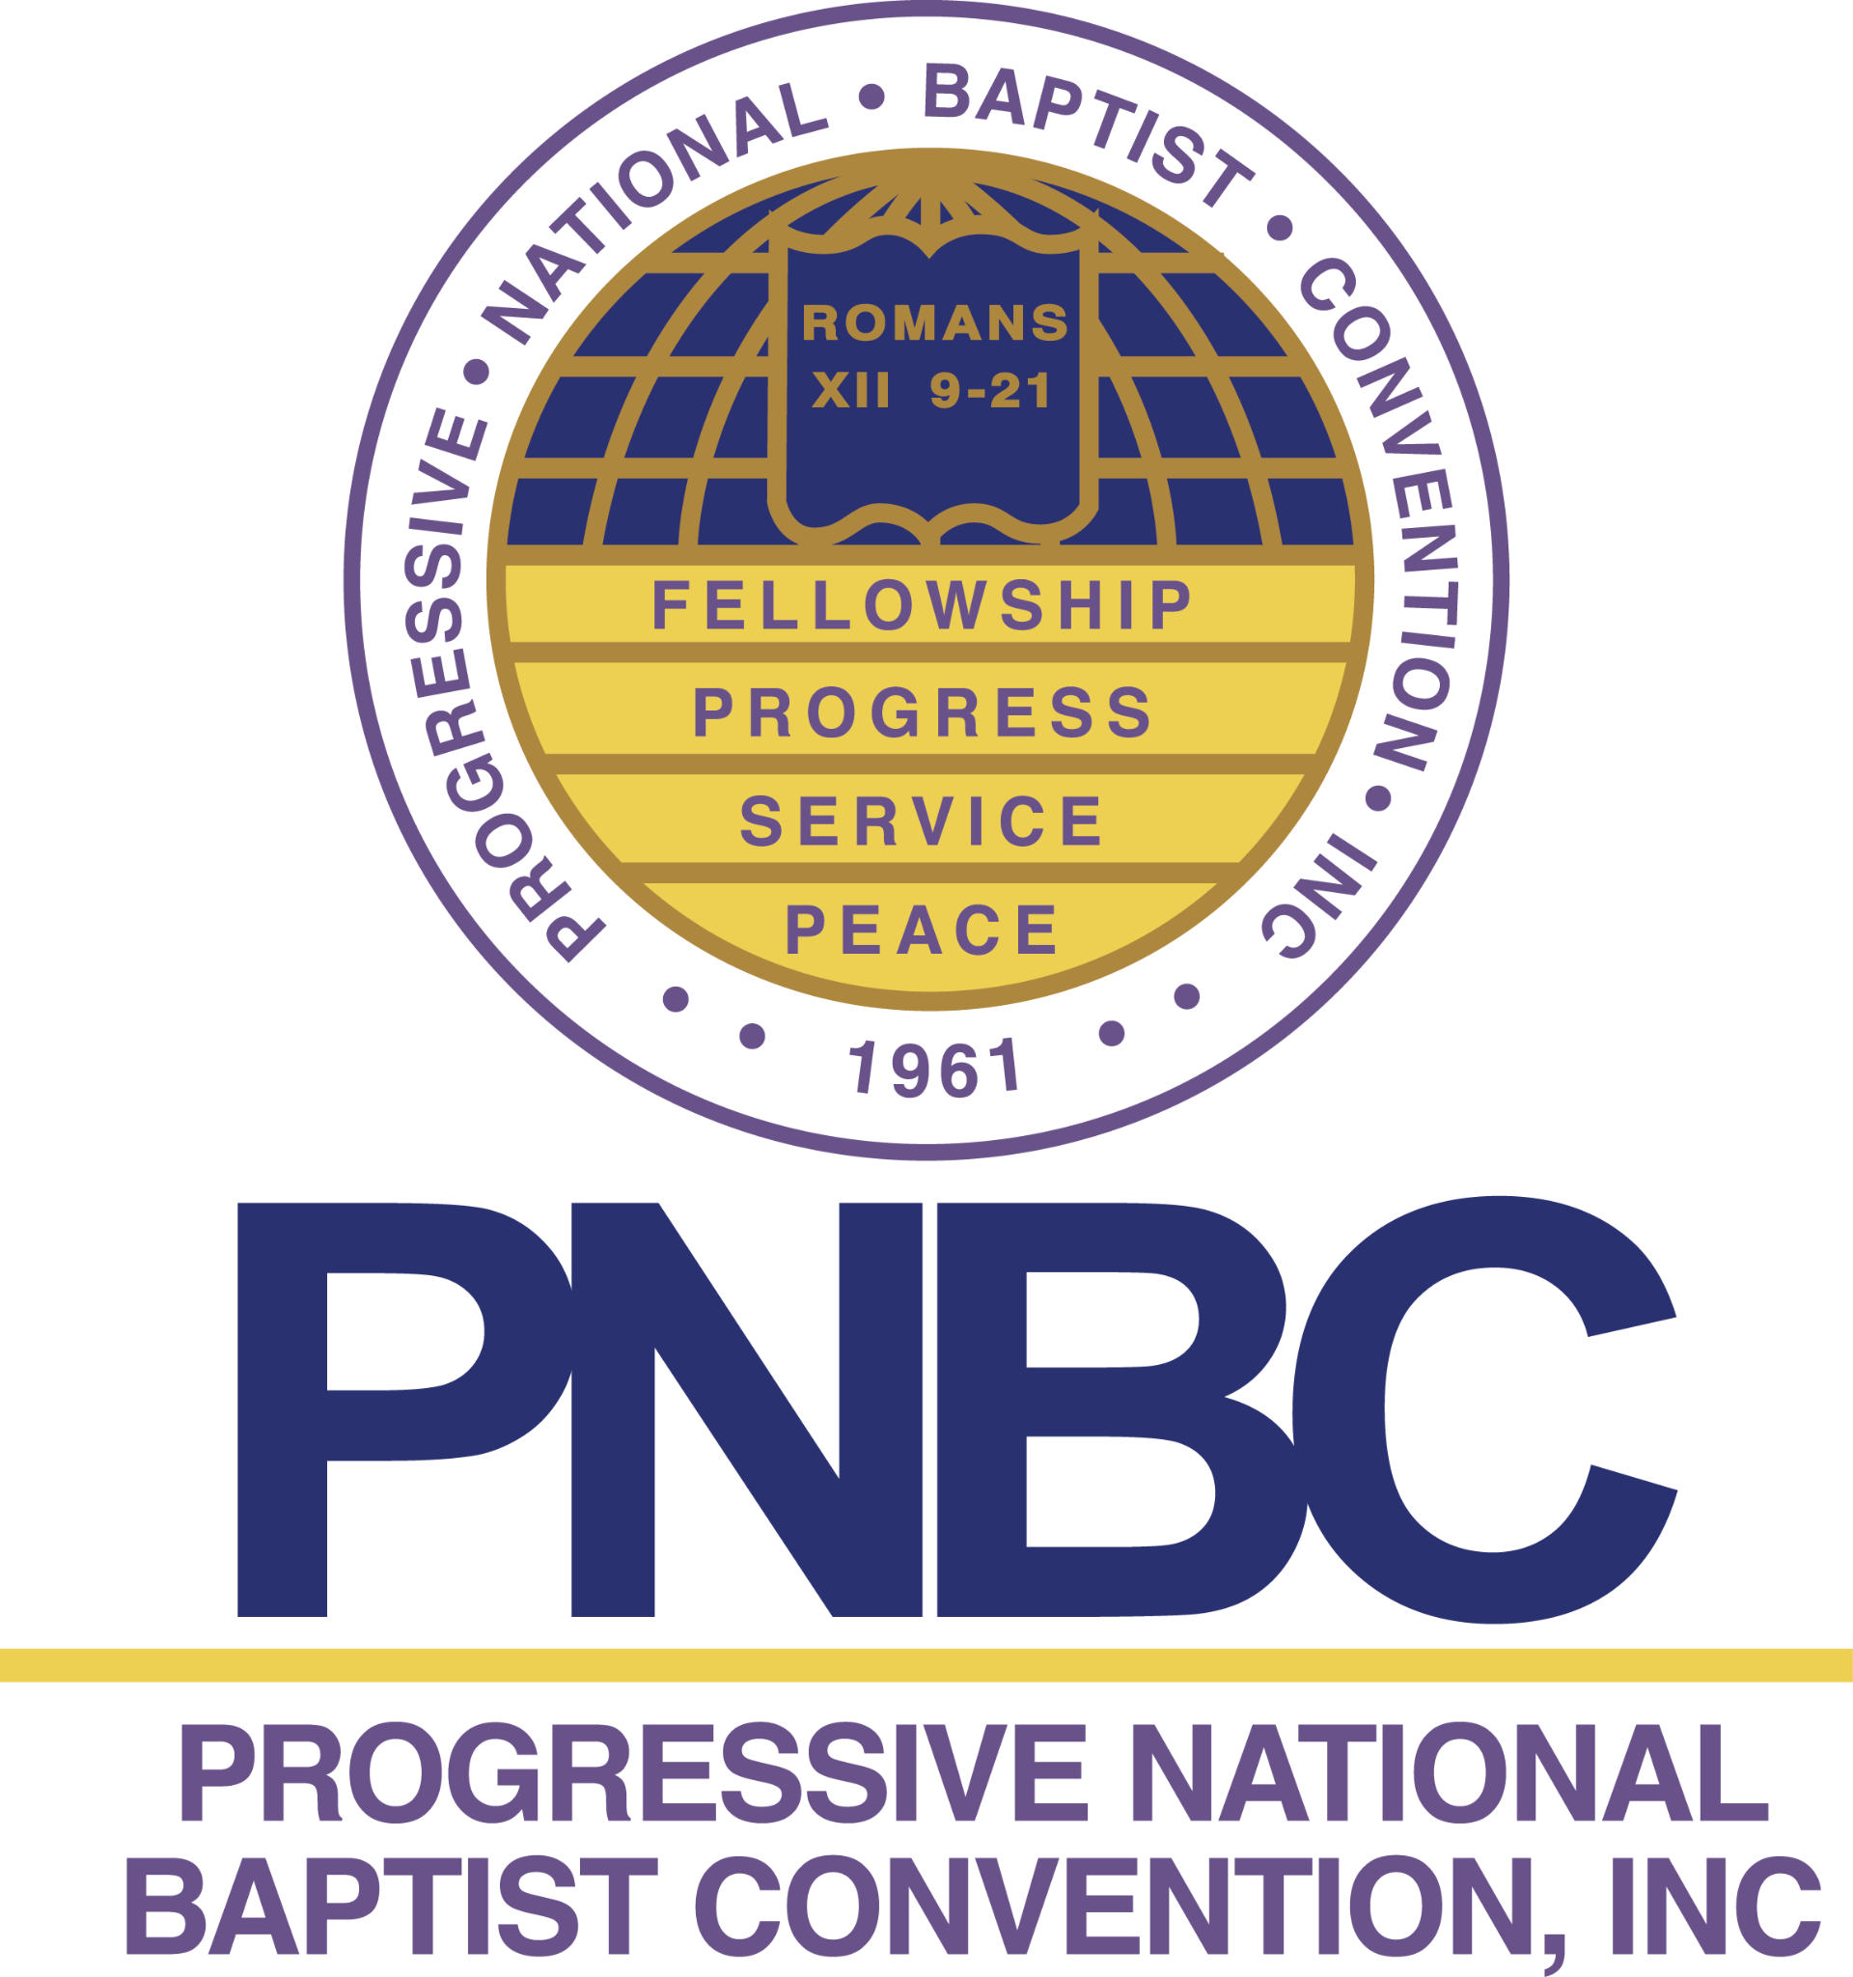
John Lewis Voting Rights Support Toolkit January 2022

Background

Since January 2021, 48 states have introduced 389 bills that amount to shameful, outright voter suppression, and many have already become law. These laws suppress voting methods that enrich our democracy and lead to high turnout: banning ballot drop boxes and mail-in voting, reducing early voting days and hours, restricting who can get a mail-in ballot, prohibiting officials from promoting the use of mail-in ballots even when voters qualify, even criminalizing the distribution of water to voters waiting in the long lines these laws create.

Passed in 1965 following Bloody Sunday, the Voting Rights Act (VRA) transformed electoral participation in our country. While the VRA included several provisions, there were three critical components:
- It prohibited discrimination based on race or ethnicity empowering people to challenge discriminatory voting practices in court.
- It established a formula to identify specific areas that had a history of discriminatory voting practices. These areas included states, counties, cities and townships across the country.
- It required these specific areas to get approval from the U.S. Department of Justice before they could make changes to their elections. This process is known as preclearance. Given their histories, these areas could not be trusted to establish non-discriminatory election-related policies on their own. Preclearance provided a process in which these areas could make changes to their elections and voting-related policies so long as the proposed policies did not discriminate.

The VRA was reauthorized with overwhelmingly bipartisan support five times, including as recently as 2006. Those renewals included several additions and expansions to the policy. The VRA is widely considered one of the most important pieces of legislation in our country’s history.

In 2013, the U.S. Supreme Court ruling in Shelby County v. Holder gutted The Voting Rights Act of 1965. The Court recognized that discrimination still existed and preclearance was still needed, but it ruled the formula used to determine which areas were required to seek preclearance was outdated. It called on Congress to update the formula.
In the eight years since the Shelby decision, Congress has failed to pass a new formula resulting in a significantly weakened VRA. Without a formula, areas with a long history of discrimination do not have to get permission from the federal government to change their election-related policies. That means, it is open season for voter suppression.

The John Lewis Voting Rights Advancement Act (H.R. 4 / S 4) is proposed federal legislation that ensures any changes to local or state elections are federally reviewed — a process known as preclearance, which was part of the original Voting Rights Act of 1965. The bill would restore the full protections of the original, bipartisan Voting Rights Act, including:
- Creating a new coverage formula that hinges on a finding of repeated voting rights violations in the preceding 25 years, measured on a rolling basis.
- Establishing “practice-based preclearance” for reviewing voting changes focused on measures that have historically been used to discriminate against voters of color.
- Electoral districts that qualify for preclearance will be covered for 10 years, but they can be extracted from federal review if they establish a clean record during that period.

Call To Action
Progressive National Baptist Convention Inc. was born in the height of the civil rights movement. Attacking the voting rights act is a challenge to the legacy of our convention and to democracy. As a convention and Christ centered believers we must respond to this attack on human liberty.

Regional and State Leaders
- Contact regional and state pastors to ensure that they are informed and equipped to mobilize their members in support of the John Lewis Voting Rights Act.
- Have a voice in the public square, write op-eds for your local media outlets, calling for congress to pass (H.R.4 / S4) immediately.
- Send letters or emails on behalf of your region or state to the Senate urging the passing of (S4)
*see email template below*
- Empower your congregation by sharing on Sunday morning the attached video from President Peoples or Posting the attached statement in your Sunday bulletin
- Make a statement to your congregation about the importance of the bill and invite them to make a call to your state senators before January 17, 2022.
- Post one of the attached graphics on your social media.

Pastors
- Send letters or emails to your two state senators (Click to find your senators) on behalf of your church urging the passing of (S4)
*see email template below*
- Empower your congregation by sharing on Sunday morning the attached video from President Peoples or Posting the attached statement in your Sunday bulletin
- Make a statement to your congregation about the importance of the bill and invite them to make a call to your state senators before January 17, 2022.
- Post one of the attached graphics on your social media.

Associate Ministers and Congregation Members
- Send letters or emails to your two state senators (Click to find your senators) urging the passing of (S4)
*see email template below*
- Empower your friends and family by sharing the attached video from President Peoples or posting the attached graphic to your social media.

Church Bulletin Insert Statement
Since January 2021, 48 states have introduced 389 bills that amount to shameful, outright voter suppression, and many have already become law. The Progressive National Baptist Convention Inc. (PNBC) is demanding that congress take action to protect our right to vote. The John Lewis Voting Rights Advancement Act (H.R. 4 / S 4) is proposed federal legislation that ensures any changes to local, or state elections are federally reviewed — a process known as preclearance, which was part of the original Voting Rights Act of 1965. The bill would restore the full protections of the original, bipartisan Voting Rights Act. We too support our convention in demanding that congress act. We invite all our members to call or email both of our state senators demanding that they pass the John Lewis Voting Rights Advancement Act. To get contact information for senators visit: www.senate.gov/senators/senators-contact.htm

Email / Letter
Subject
Pass the John Lewis Voting Rights Advancement Act

Body
As your constituent, I urge you to pass the John Lewis Voting Rights Advancement Act. Passing the VRAA will protect our fundamental right to vote and defend us against discrimination.
The removal of critical protections from the Voting Rights Act of 1965 catalyzed a race to stop people of color from voting. Since then, states have been able to engage in voter suppression with impunity. In 2021 alone, 34 anti-voter laws passed in 19 states, often purposefully targeting people of color through tactics including restraints on voter registration and absentee voting, racially gerrymandered district maps, and more. And given the Supreme Court’s most recent 2021 decision in Brnovich v. Democratic National Committee, which unduly narrows the Voting Rights Act – it is clearly up to Congress to do what is necessary to protect the rights of all voters in this country.

The price of inaction is high, and history shows it. With midterm elections fast approaching, I’m asking you to act now to cement the legacy of the Voting Rights Act and guard the rights of all Americans.
It's long past due for Congress to renew vital voting protections. Pass the John Lewis Voting Rights Advancement Act now.
Sincerely,
[First Name] [Last Name]

Digital Tools
Download video from President Peoples for church announcements:
https://drive.google.com/file/d/1vg9S8AQrYXtoUKcwi_lZEZK2HGZdu0jn/view?usp=sharing

Link to social media graphics : https://www.canva.com/design/DAE1WSV07MM/gVgpAKDbDn7ILjzf28aRog/view?utm_content=DAE1WSV07MM&utm_campaign=designshare&utm_medium=link&utm_source=publishsharelink

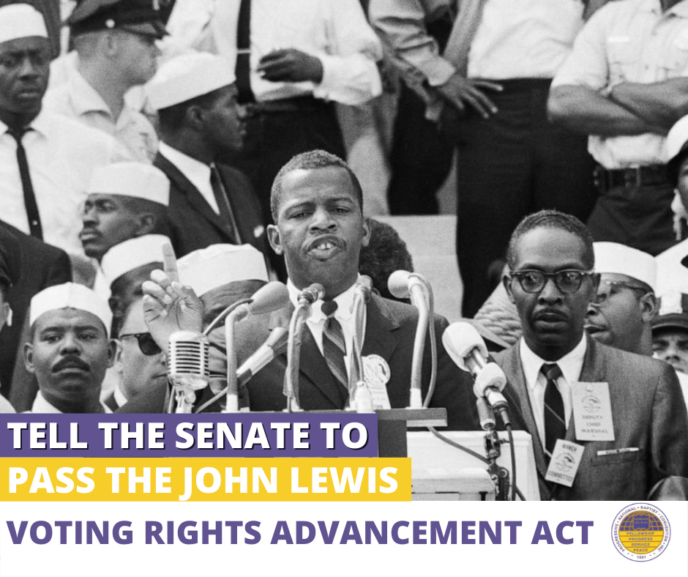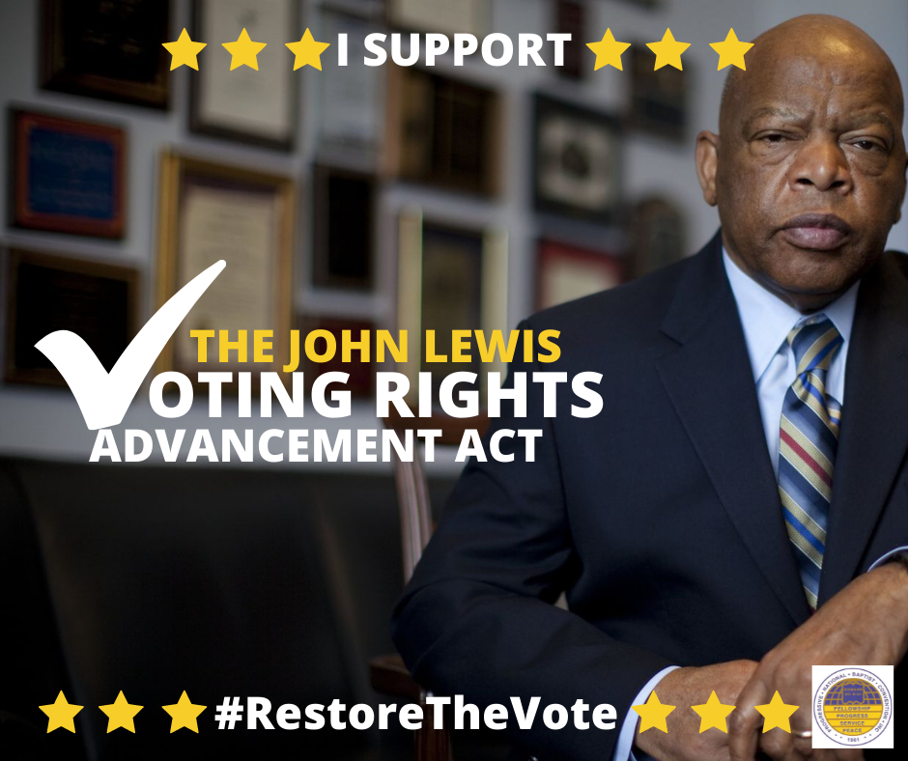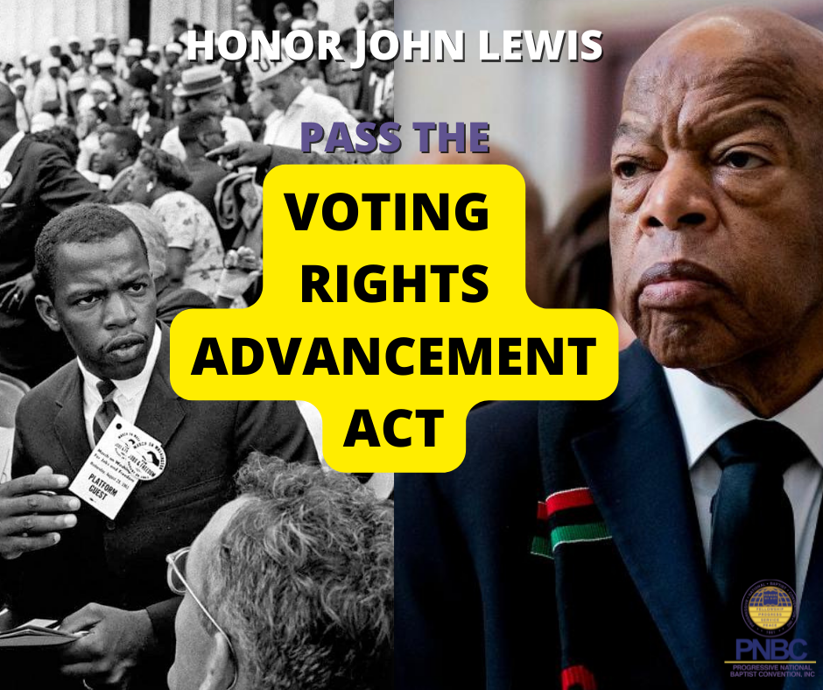

Resources and Links

S.4 - John R. Lewis Voting Rights Advancement Act of 2021

https://www.congress.gov/bill/117th-congress/senate-bill/4/text

Statement by President Biden on the John R. Lewis Voting Rights Advancement Act
https://www.whitehouse.gov/briefing-room/statements-releases/2021/11/03/statement-by-president-biden-on-the-john-r-lewis-voting-rights-advancement-act/

Congressional Black Caucus calls for Senate action on voting rights
https://kansasreflector.com/2022/01/12/congressional-black-caucus-calls-for-senate-action-on-voting-rights/
Black Pastors on hunger strike for voting rights
https://www.washingtoninformer.com/black-faith-leaders-launch-hunger-strike-for-equal-voting-rights/

NATIONAL CALL FOR MORAL REVIVAL RALLY AND MARCH TO THE CAPITOL
https://www.pnbc.org/national-call-for-moral-revival-rally-and-march-to-the-capitol-2

For The People Act

EXPANDS VOTER ACCESS
- Establishes Online Voting
- Requires Same Day Registration
- Requires at least 2 weeks Early Voting
- Expands No Excuse Absentee Voting
- Stops Purging
- Restores Voting Rights for Former Felons
- D.C. Voting Rights and Statehood

ELECTION INTEGRITY AND SECURITY
- Provides Paper Ballots for back up & audits
- Mandates Election Audits
- Prevents Voter Intimidation
- Penalties for Disinformation
- Bans Partisan Gerrymandering

POLITICAL SPENDING LIMITED
- Requires organizations to disclose spending
- Bans Foreign Nationals Contributions
- Creates Small Dollar Matching

ETHICS
Expands Conflict of Interest Requirements for White House and other Federal Employees
Requires candidates for President and Vice President to submit 10 years of tax returns

