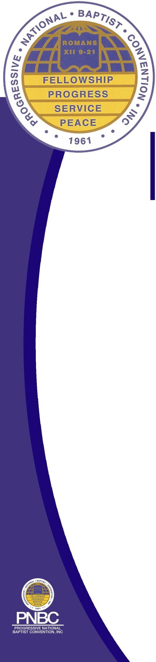

April. 2022

Dear Prospective Exhibitor:

The 61st Annual Session of the Progressive National Baptist Convention, Inc (PNBC) will convene this year in Orlando, Florida August 7-12, 2022, and we are inviting you to partner with us as a vendor during the week. PNBC appreciates the support of all of our vendor partners, old and new, and we welcome the opportunity for your business to market your signature brand to the approximate 2,000+ participants expected at this year’s session.

All meetings and gatherings will be held at the Hilton Orlando, 6001 Destination Parkway, Orlando, Florida 32819. Reservations at the Hilton may be made by calling the Hilton direct at 1-888-488-3509 or press “enter” on the following link <https://bit.ly/PNBCAS22>

Enclosed with this letter are the PNBC booth price list, setup and exhibit times, exhibit contract and the PNBC rules and regulations.

Included in the cost are a 10x10 booth, pipe and drape, identification sign, a table, two (2) chairs, and one wastebasket. Any additional decorating equipment and electrical needs are at the expense of the exhibitor. All spaces are assigned on a “first-come, first-served” basis and we ask that you please return your application along with full payment to PNBC Headquarters by Friday July 15, 2022. Payment can only be received in the form of a certified check, money order or credit card. Any application received with a personal check for payment will be returned. Additional information concerning the PNBC 61st Annual Session may be found on our web site at: www.pnbc.org

Once payment has been received you will receive the official exhibitor prospectus that will assist you in ordering labor and the shipping of your material.

Should you have any questions or need additional clarification after reviewing the attached documents, please contact Meetingsandevents@pnbc.org.

Sincerely,

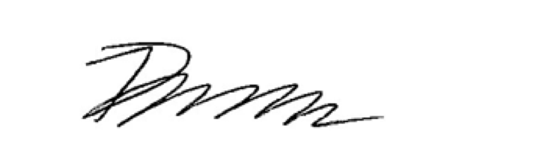

Dr. A. Wayne Johnson

General Secretary

PROGRESSIVE NATIONAL BAPTIST CONVENTION, INC.

601-50TH STREET, NE

WASHINGTON, DC 20019

(202) 396.0558 or (800) 876.7622 TOLL FREE

WWW.PNBC.ORG

*In honor of our beloved 21st President Dr. Timothy Stewart*

REV. DAVID R. PEOPLES

**PRESIDENT**

DR. KEITH W. BYRD, SR.

**1ST VICE PRESIDENT**

DR. A. WAYNE JOHNSON

**GENERAL** **SECRETARY**

**PROGRESSIVE NATIONAL BAPTIST CONVENTION, INC.**